**Row Echelon Form**

* All zero rows, if any, belong at the bottom of the matrix
* The [leading coefficient](https://en.wikipedia.org/wiki/Leading_coefficient#Linear_algebra) (the first nonzero number from the left, also called the [pivot](https://en.wikipedia.org/wiki/Pivot_element)) of a nonzero row is always strictly to the right of the leading coefficient of the row above it (some texts add the condition that the leading coefficient must be 1)

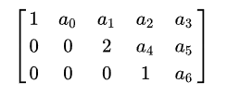

**Reduced Row Echelon Form**

* It is in row echelon form.
* The leading entry in each nonzero row is a 1 (called a leading 1).
* Each column containing a leading 1 has zeros everywhere else.

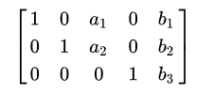

**Multiplying Matrices**

* Multiplying matrices is associative, but **not** communitive
  + (AB)C = A(BC)
  + ABC != CBA
* You can only multiple two matrices if the columns of the first matrix equal the number of rows of the second matrix
  + The result is a matrix with the rows of the first matrix with the columns of the second matrix
* Multiplying 2 matrices uses the dot product
  + 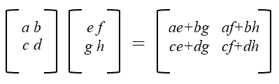

**Identity Matrix**

* A square matrix in which all the elements of the principal diagonal are ones and all other elements are zeros.
  + The effect of multiplying a given matrix by an identity matrix is to leave the given matrix unchanged.
  + 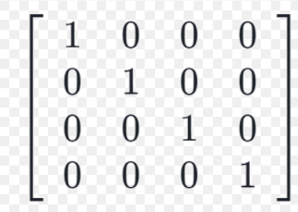The identity matrix is like decimal value 1 (A*1 = A)

**Determinant of a Matrix**

* + Only an n*n (square) matrix has a determinant
  + 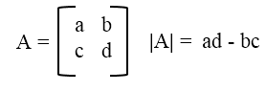N = 2 matrix:
  + N = 3 matrix:
    - 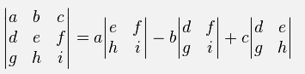a11M11 - a12M12+ a13M13
    - Mxy is the minor determinate
  + N = x
    - Continue the pattern for a N = x matrix

**Inverse of a Matrix**

* + 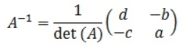2x2 matrix:
  + 3x3 matrix:
    - 1/det(A) *Adj(A)
      * Adj(A) is a matrix formed with the determinates of the minor matrices

**Transpose of a Matrix**

* Swap the rows with the columns, and vice versa

